Part A: System Design Documents (20 points)

* System requirements
  + dataFile.txt – code to make completed
  + table for core – make it easier to utilize multiple
* Process entity support (Process Table, PCB, etc)
* Description of multicore process distribution approach
  + Load Sharing (FCFS) – one queue that all the cores pull from
  + Dedicated Processor Assignment – a process is scheduled to be run on just one processor (any wait time is time the CPU isn’t running)
  + Gang scheduling – decompose the process into several threads and run them simultaneously across the cores
* Description of Uniprocessor multiprogramming scheduling
  + FCFS – the first process in the ready queue is the first process that is run on the core
  + Shortest Process Next – whichever process in the waiting queue is run next on the core
  + Feedback – multiple levels of queues, the highest level is for shortest process…
  + Round Robin – the first process in the queue goes first but this is preemptive, and any process over the quantum are placed back in the ready queue
* UML Diagrams

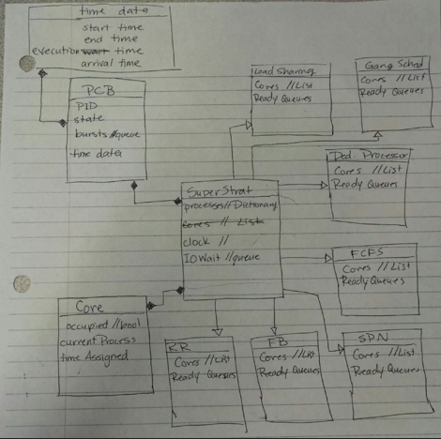

* Project Management Plan
  + Project on GitHub – try to work over Spring Break, reconvene after to go from there
  + Johnny is project manager ☺
* Deliverables each team member is responsible for?
  + Johnny will play with datafiles
  + Lucas will play with processes n info
  + Katie will play with different scheduling strategies
* Milestone deliverable dates
  + Have something to show after Spring Break
  + Small components done by Thursday after spring break
  + Then connect the dots!
* Diagram of multilevel queue configuration & scheduling algorithms